**Drawing Legal Descriptions in ArcPro**  
Last updated 2/22/2021

To draw parcels from legal description I recommend you create a line feature called “Temp Line”. This feature will be used to draw all the new parcels and can be edited/altered when needed. Once you create your new parcels you can start an edit session on the Preliminary Parcel layer and trace your Temp Line to create your new parcels. More details below.

When reading a legal description to draw a new parcel you’ll need to determine a correct starting point. This is usually a section corner, quarter section, or other identifying marker. This will be where you start your drawing but may not be the “true point of beginning”. The “true point of beginning” is the portion of the legal to which the actual parcel is created.

Your workspace should have parcels, temp line, preliminary parcels, roads, section, survey monuments and any other identifying features to help you locate your starting point.

Steps for drawing a new parcel:

1. Enable editing on your temp line or preliminary parcel feature
2. Choose “create” a new feature  
   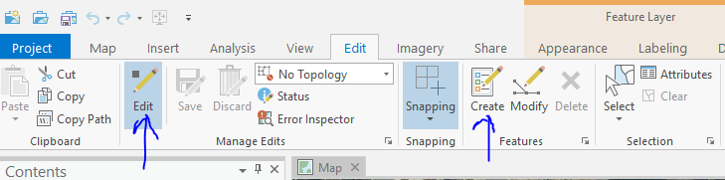
3. Under tools open the drop down and navigate to “Traverse”  
   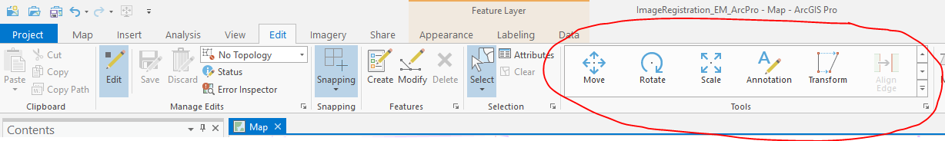
4. Select “Set Start Location”
5. Determine starting point (often section corner) and place your cursor there and click. (Be sure it snaps to the line/corner you want it to or your entire drawing will be shifted)  
   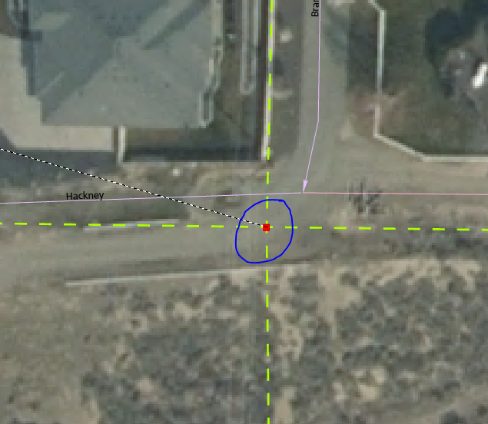
6. Once you’ve set your starting point you will see the option to input direction and distance.  
   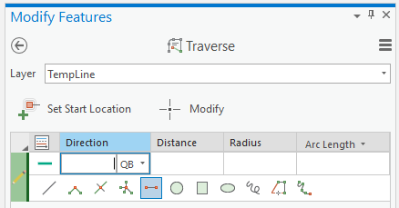
7. Start adding the information for direction and distance from the plat/legal description that shows bearings (direction) and distance

Directions (bearings) are input like this: N00-25-34W

Note: if the direction looks wonky once you’ve entered the data you likely need to swap N/S or E/W. Keep the numbers the same but swap north for south and east for west or vice versa. The swap will be a complete mirror of what it was. i.e. if it *was* N00-25-34W it will now become S00-25-34E. You need to change both directional units, not just one.

1. Repeat step 7 as many times as you need to complete the parcel. You can go back and adjust lengths if you made a mistake or delete entire segments. If you need to stop your drawing just save your edits and start again by setting your “start point” where you left off.
2. Sometimes you will have to draw a curve. Follow these instructions:

Right click in your map and select “circular arc” – this window will appear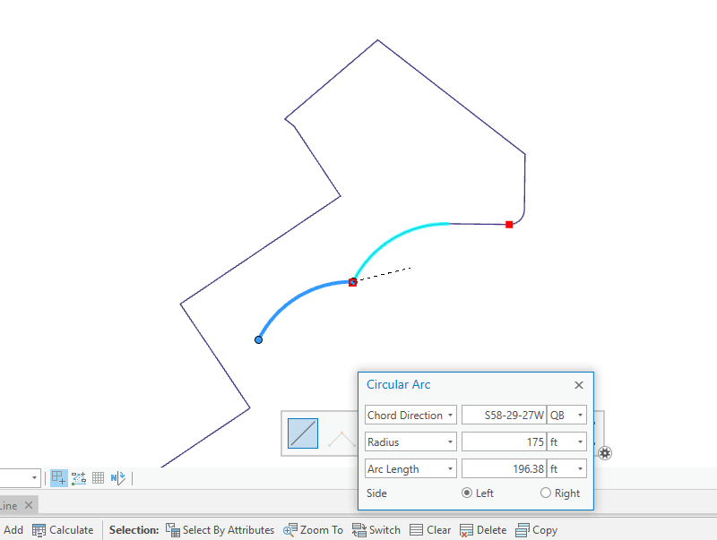

You’ll need to input the information from your plat or legal description and specify if the curve is to the right or left.

1. Save edits throughout the process to ensure no loss of work
2. Once you’ve completed all parcels save edits and stop editing
3. Start a new edit session on Preliminary Parcels and trace the outline of each individual parcel you created to create new preliminary parcels. You’ll need to enter information on each of the new parcels such as parent parcel number, lot, plat, etc.
4. Save and stop editing